|  |  |  |  |  |  |
| --- | --- | --- | --- | --- | --- |
| Date | 29-Nov-22 | | | Tester Name | Shahabuddin Syed |
| Environment | Select Environment | | | Login used |  |
| Operating System | Windows | Version: | Update: | | |
| Software Used | Edge | Version: | Update: | | |
| Select Software | Version: | Update: | | |
| Release version | 22.4.1 | | | | |
| Title |  | | | | |
| Test Type | Regression | | | | |
| Test Scenario | Change multiple things at once | | | | |
|  |  | | | | |
| Expected Results |  | | | | |
| Pass/Fail | Pass | | | JIRA# | N/A |

Describe your steps with screenshots:

In PENFAX5 Look for a member with Active status.

Keep track of their employer, current scope code, department, Employee type, Name and EEID

SID# 317572

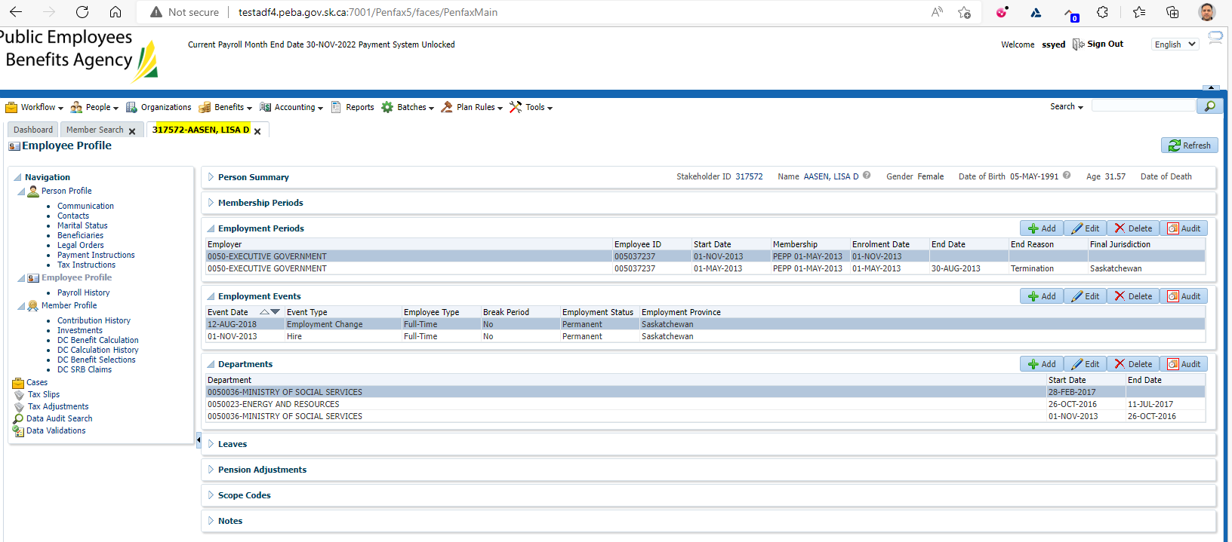

Log into DCT

Select the employer from step 1

Click on Create New File

Select Status Change from the dropdown

Click Create

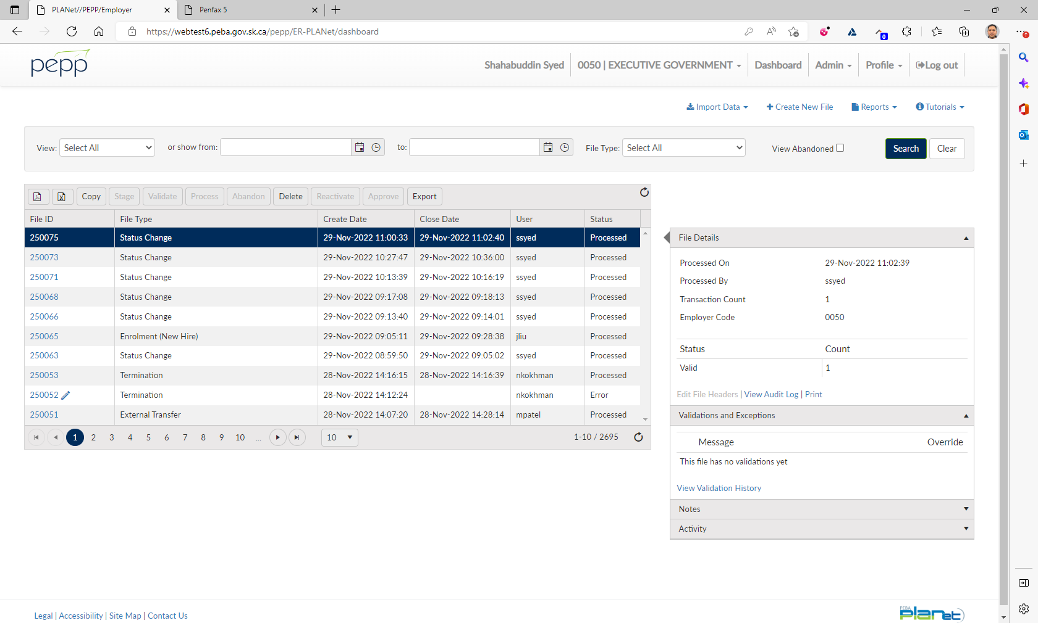

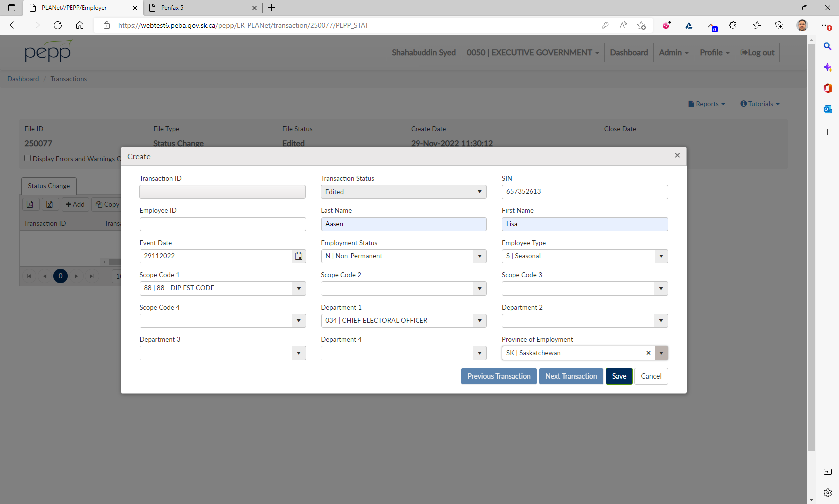

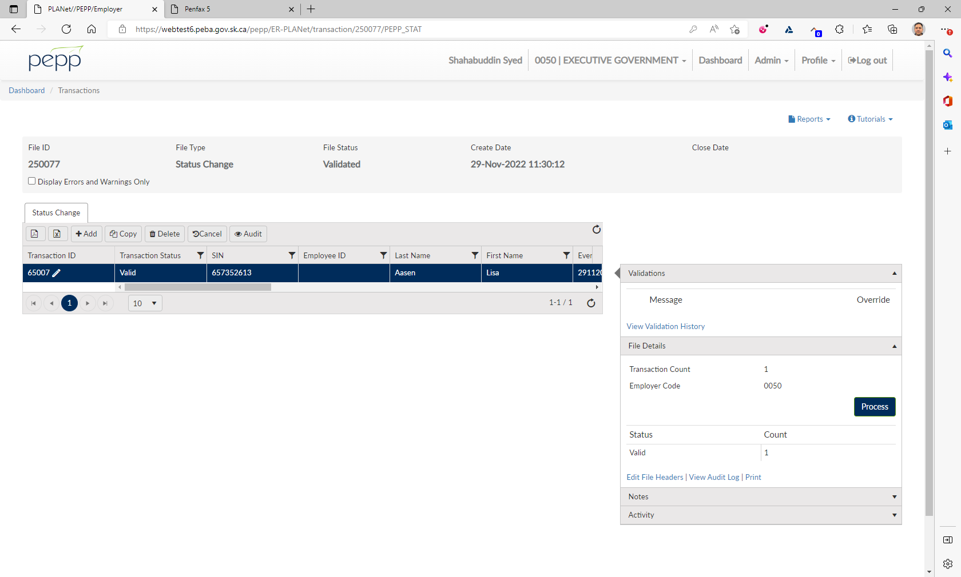

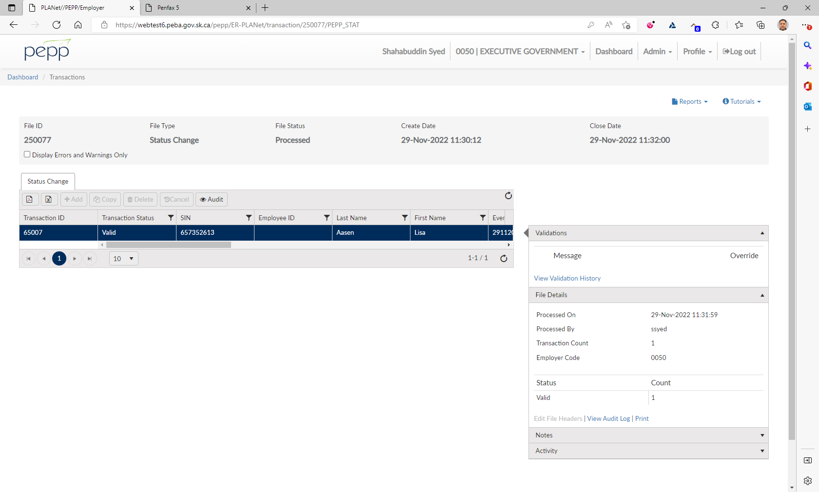

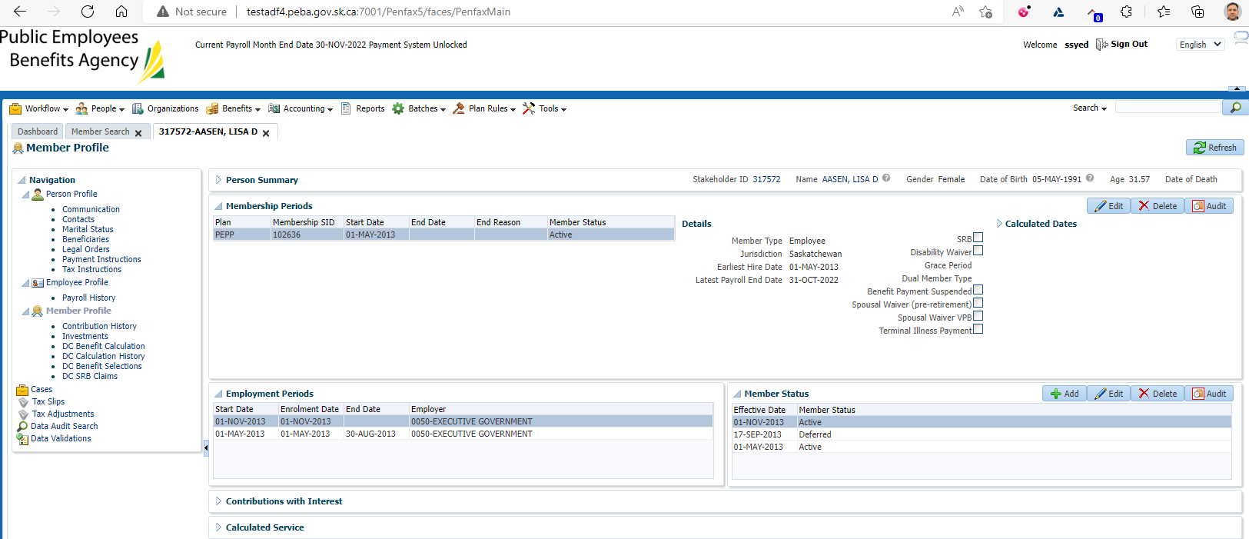

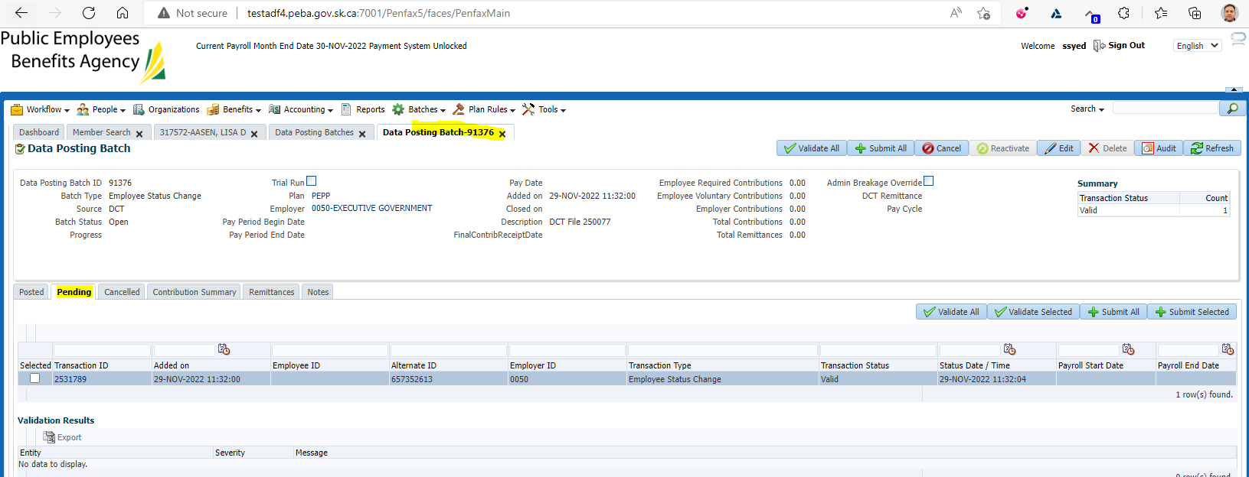

Status shows as Pending

Click on Validate All and then Submit All

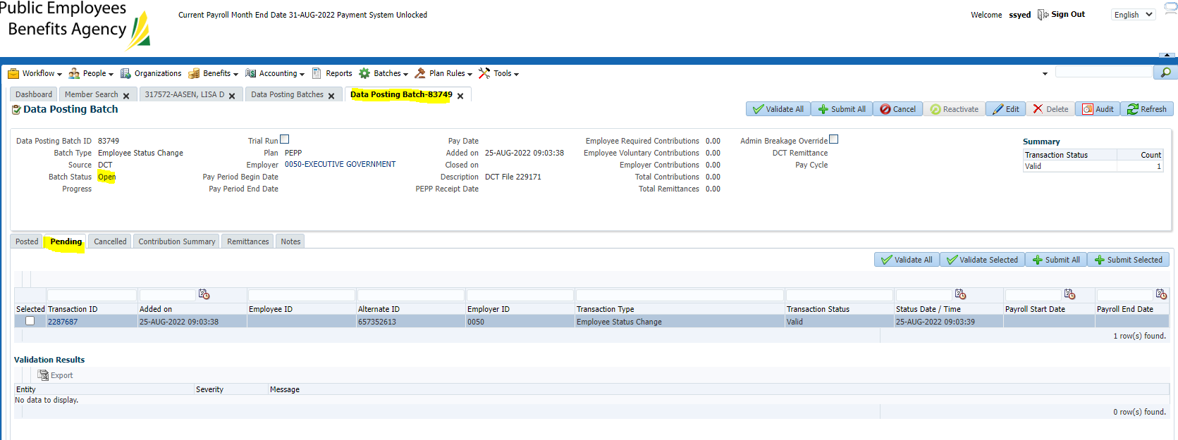

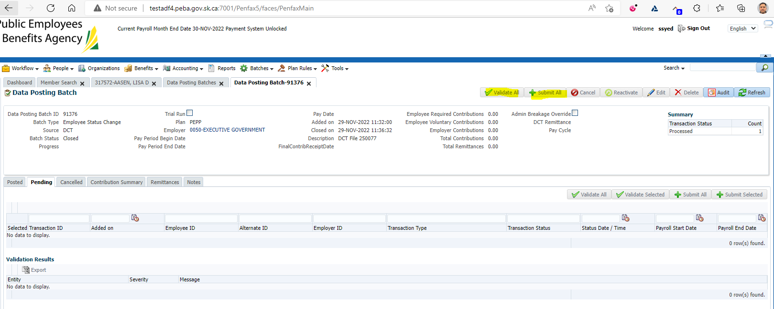

Data Posting batch showing status as Posted

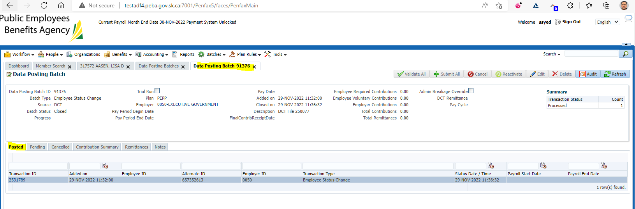

Under Scope Codes the new scope code should be listed

Under Department the new status should be displayed and end date will be in the previous Department

Under Employment events, there will be a new Employment change with the new employee type

End date should populate for the previous scope code

